**The Iteration Method**

**Theory**

It is a method that requires one starting value of x. This value doesn’t need bracket the root. For finding the root of the equation f(x)=0 it is needed to rewrite the equation in the following form, x = G(x). Then the value of x is assumed. An then in each iteration the value of Xn and the value of Xn+1 is determined along with their difference. This iteration continuous until,

Eps * (1- max (G`(x)) )

[m,n]

| Xn+1 – Xn | < --------------------------------

max (G`(x))

[m,n]

Where, Eps = the given error rate decimal point e.g. 10^-4

m = lower limit

n = upper limit

**Code**

#include<bits/stdc++.h>

using namespace std;

#define Error (0.0001 * (1-0.1602))/0.1602

double f(double x)

{

return pow((5-x),(1.0/3.0));

}

double Iteration(double x)

{

int i=0;

double xn=x,m=f(x);

cout<<"-------------------------------------------------"<<endl;

cout<<"| i"<<" | "<<"x"<<" | "<<"xi + 1 | Error Rate |"<<endl;

cout<<"-------------------------------------------------"<<endl;

do

{

xn = m;

m = f(xn);

printf("| %d | %0.5lf | %0.5lf | %0.6lf |\n",i,xn,m,fabs(m-xn));

i++;

}while(fabs(m-xn)>=Error);

cout<<"-------------------------------------------------"<<endl;

cout<<"The value of x is: "<<m<<endl;

}

int main()

{

double a;

cout<<"Enter the value of x: ";

cin>>a;

Iteration(a);

return 0;

}

**Output**

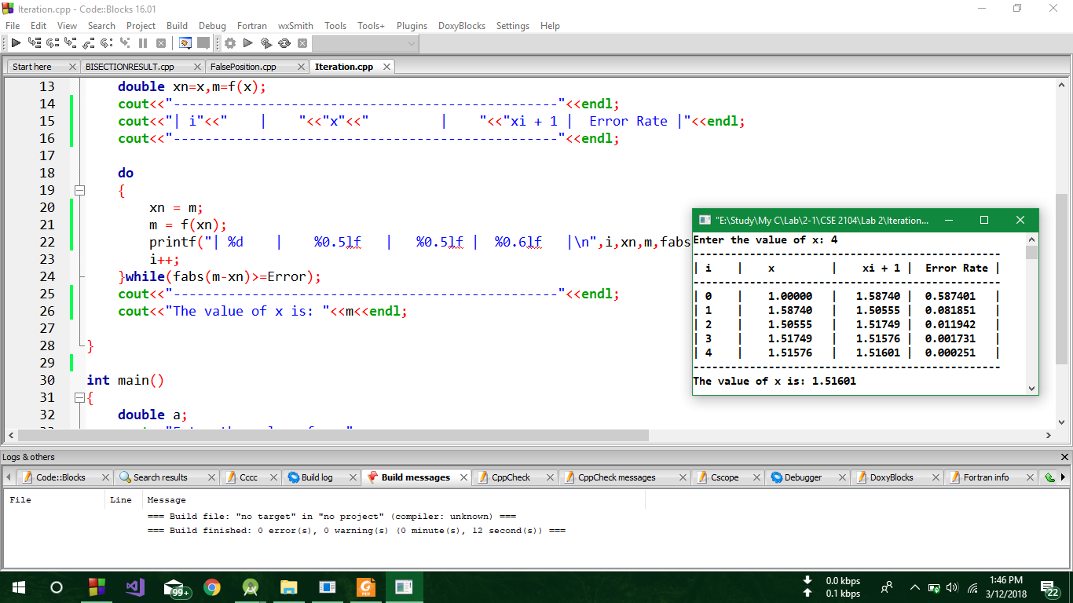

**Discussion**

In the following code, In the function named Iteration(), At first f(x) return value was assigned to m and x was assigned to Xn then a do while loop was used where the value of m was assigned to Xn and the return value of f(xn) was assigned to m. After that the value of I,xn,m and the difference of two consecutive x’s value were printed as a tabular form.